**Associate Producer**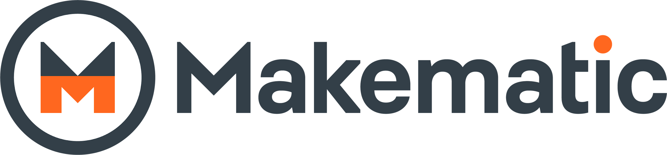

**Job Description**

An Associate Producer at Makematic is a key part of the producing team, working alongside a lead producer across any number of educational projects. The purpose of this position is to support the producer(s) both logistically and creatively.

**Key responsibilities**

* Support the production workflow from concept to delivery on assigned projects
* Follow and update standardised Makematic task management documents and platforms throughout all productions
* Work with the lead producer on development of creative treatments and research as well as the creative vision for allocated projects
* Collaborate with producers on creative decisions, such as scripting, storyboarding, visual development, and content development.
* Organise, coordinate and help develop ideas with script writing team
* Support the project team including Researchers, Animators, Script Writers, Editors and Producer
* Oversee specific segments or portions of the project.
* Help to set up and organise shoots, edits, and audio mixes, and coordinate schedules.
* Liaise with and guide animators and editors throughout the post production process.
* Assist producer with invoices and cost tracking and help manage budget
* Communicate with relevant internal and external team members professionally
* Assist with post-production tasks like scheduling, reviewing cuts, or coordinating deliverables.
* Assist in the delivery and filing of 3rd party agreements, Risk Assessments and Health & Safety law
* Research and logging of archive/3rd party materials for projects
* Take responsibility for post production paperwork and metadata ensuring it is accurate and delivered on time

**Essential Skills**

* At least 2 years experience as an assistant producer or similar role
* Ability to handle a fast-paced environment
* Good understanding of the production process
* Familiarity working with clients/stakeholders
* Positive and collaborative attitude
* Attention to detail
* Research Skills
* Understanding of Copyright and Licencing
* Excellent spoken and written communication
* Excellent time management and organisation skills
* Experience working with remote edit/animation teams
* Computer literacy, specifically Google suite

**Desirable Skills**

* Experience/interest in educational content
* Experience/interest in animation and live action production
* Familiarity with Adobe Suite (Premiere Pro, After Effects, etc.)